Group 3 - Database

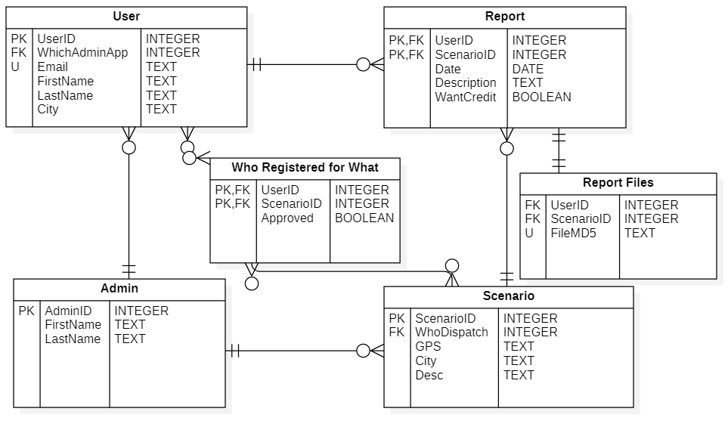

User – regular user, volunteer

1. User ID – not revealed to client, used to identify quickly on servers. (pk)
2. WhichAdminApp – which of the authorized administrator accounts authorized this user’s registration. (fk-admin)
3. Email – unique, used to send users messages, and also as a login method.
4. First & Last Name – to give users credit if they want it.
5. City – in case users don’t want to use GPS locations on app.

Admin – higher degree user who is not a volunteers

1. AdminID – used to identify them for the service.(pk)
2. First & Last Name – to identify them for external services. Only seeable by admins.

Scenario – The event call sent out by an admin

1. ScenarioID – used to identify a unique scenario. (pk)
2. WhoDispatch – which administrator created this scenario. (fk-admin)
3. GPS – coordinates string to be used by GPS-enabled volunteers.
4. City – value to be pulled by GPS-disabled volunteers.
5. Desc – short text description of the event for volunteers to know what to take pics of

Report – The report made by a single user for one scenario

1. UserID – used to identify the user who sent the report. (fk-user, pk alongside ScenarioID)
2. ScenarioID – used to identify the scenario it reports on. (fk-scenario, pk alongside UserID)
3. Date – when the report was received by the server.
4. Description – short description written by user of the event.
5. WantCredit – whether or not the user wants their name written on the report.

Who Registered for What –which users decided to register for which scenario

1. UserID – used to identify the user (fk-user, pk alongside ScenarioID)
2. ScenarioID – used to identify the scenario (fk-scenario, pk alongside UserID)
3. Approved – state of the their report being accepted by an admin or not.

Report Files – used to identify which files belong to each user report

1. ReportID – report’s identifier (fk-report)
2. FileMDS – file checksum to find on other server.